LAB EXPERIMENTS
TOPIC 1
NAME: CHANDRA KALA TORAM
REG NO: 192372224
COURSE CODE: CSA0608
COURSE NAME: DESIGN AND ANALYSIS OF ALGORITHM

EXP 1: LINEAR SEARCH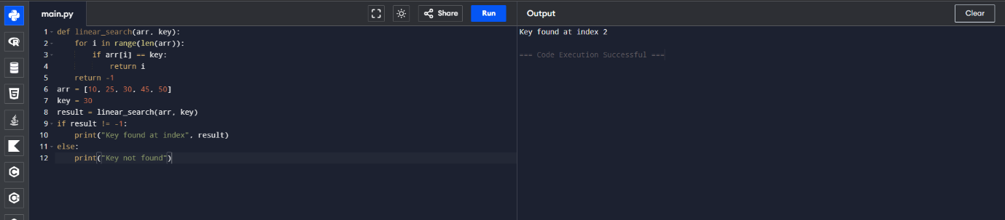
EXP 2: BINARY SEARCH
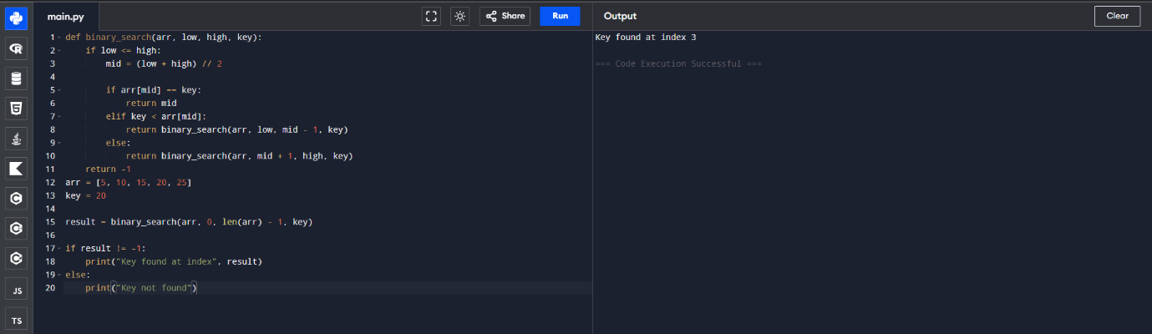
EXP 3: FACTORIAL
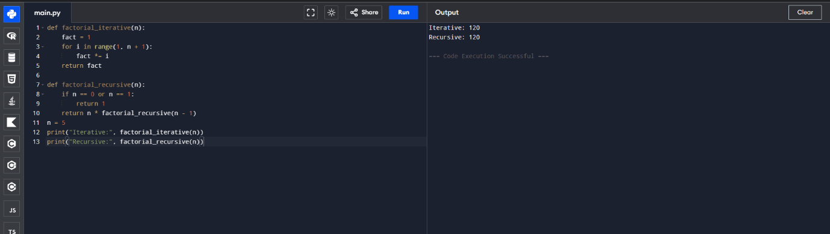
EXP 4: FIBONACCI
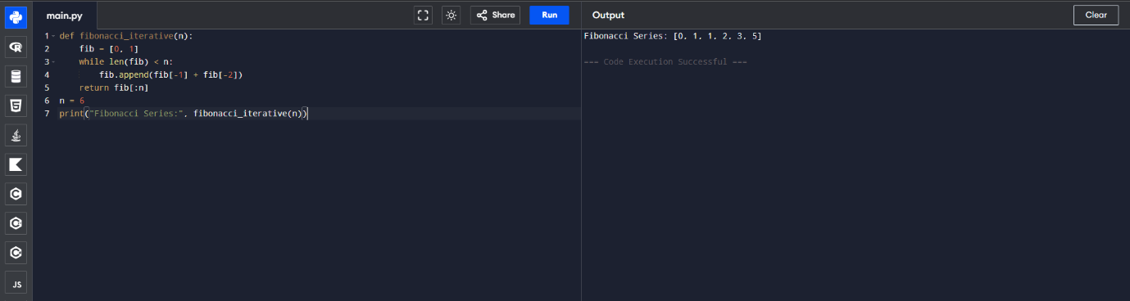
EXP 5: MATRIX MULTIPLICATION
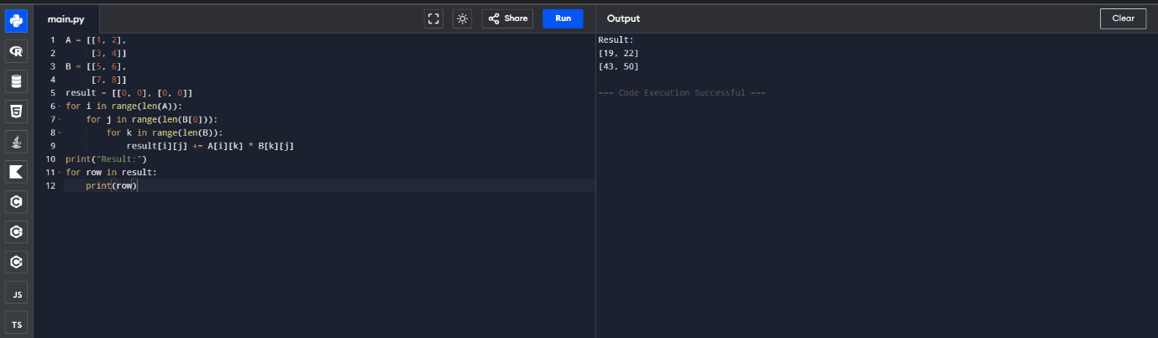
EXP 6: MERGE SORT
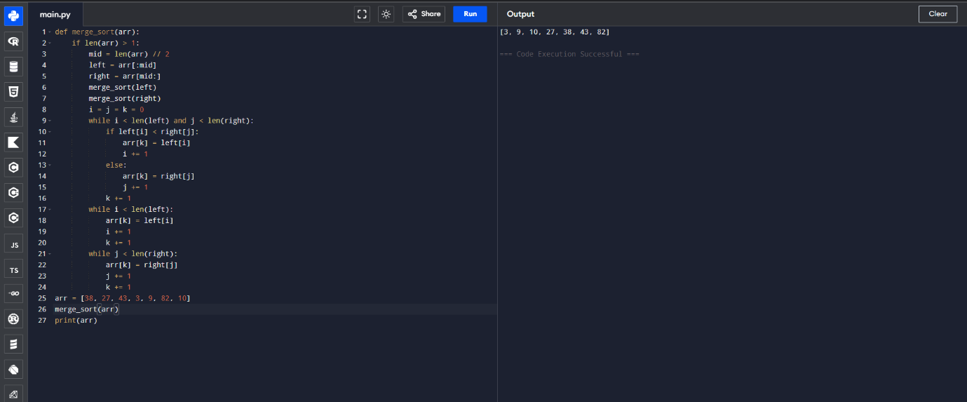
EXP 7: QUICK SORT
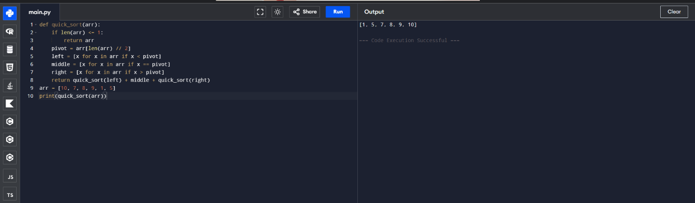
EXP 8: TOWER OF HANOI
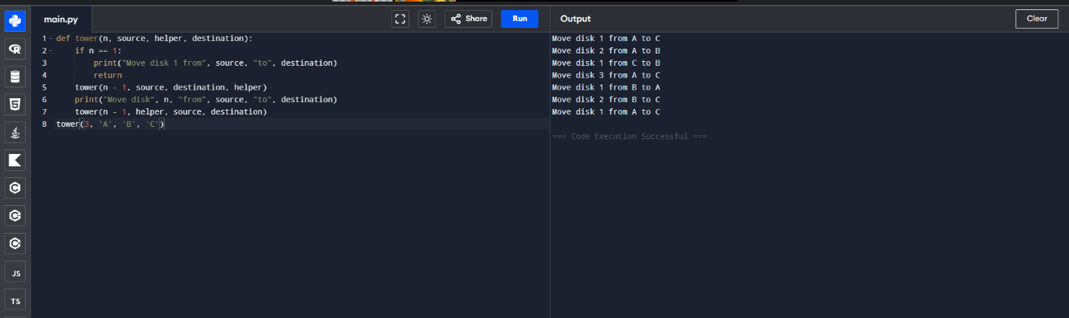
EXP 9: GCD(Euclidean Algorithm)
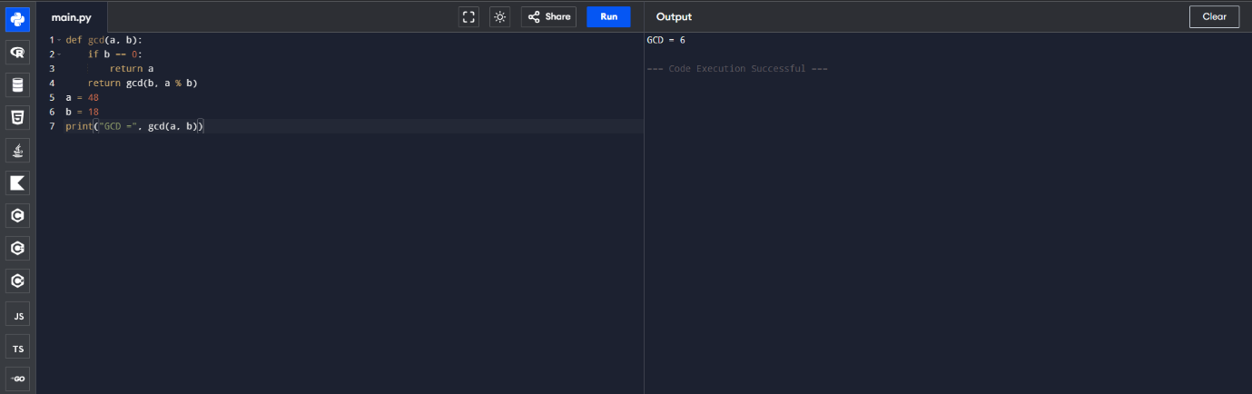
EXP 10: INSERTION SORT
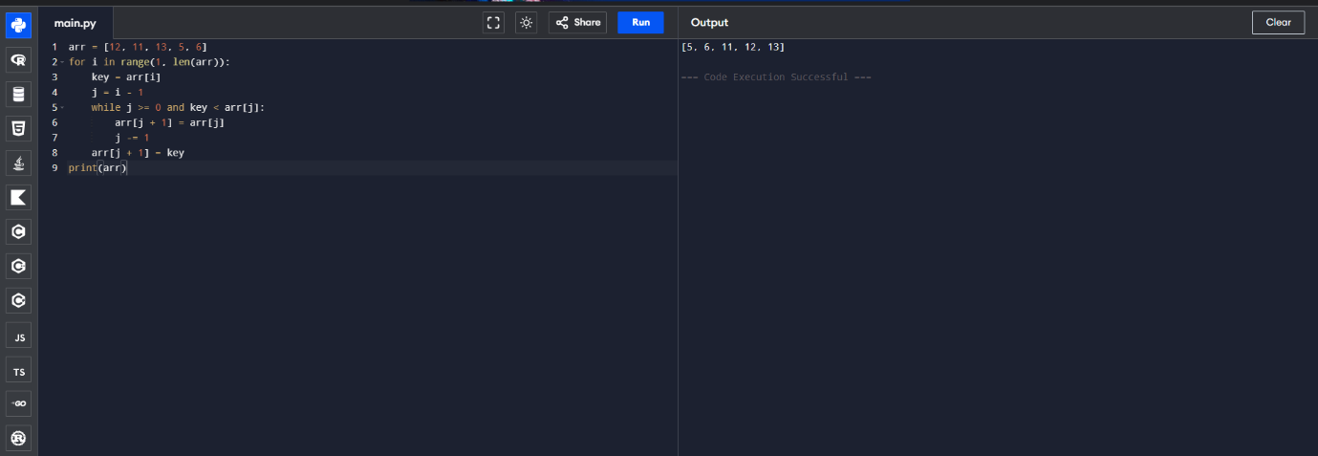
EXP 11: HEAP SORT
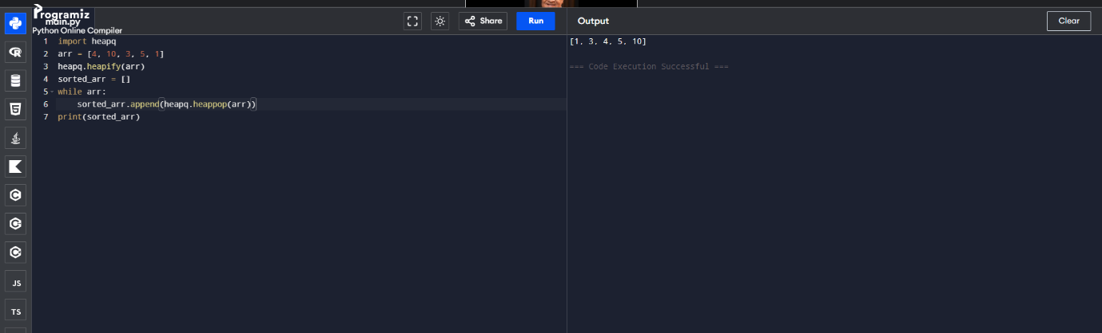
EXP 12: COUNTING INVERSIONS
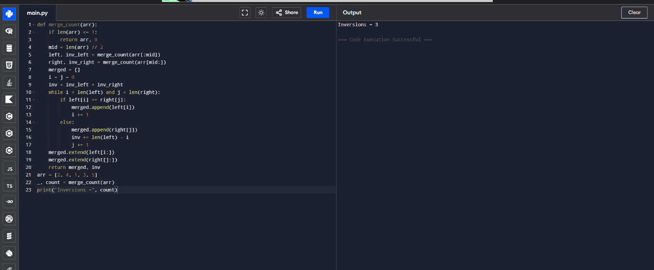
EXP 13: Maximum Subarray Sum (Kadane's Algorithm)
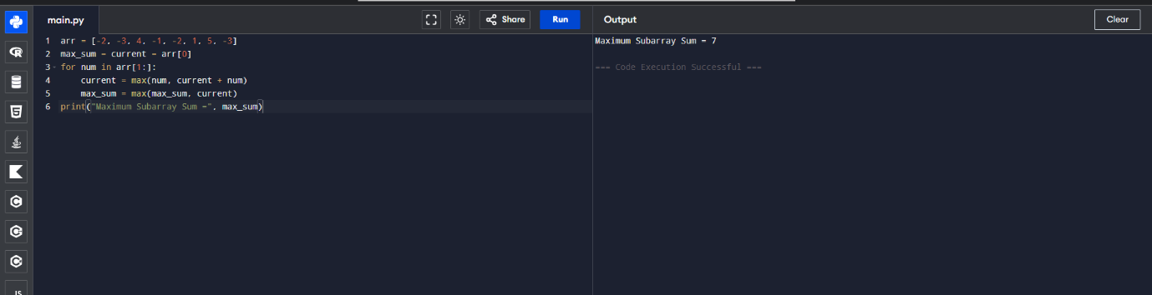
EXP 14: Exponentiation (Fast Power)
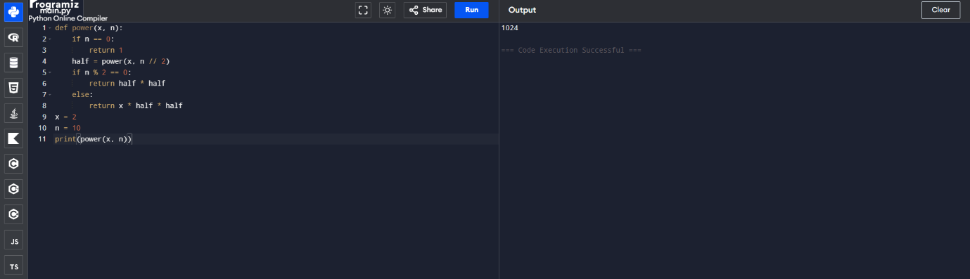
EXP 15: Closest Pair of Points (Brute Force)
